View this email in your browser



Introduction
Welcome to this October 2022 Update from Christian Values in Education.
We would take this opportunity to announce details of our November online event. and to update you on events that CViE are involved with that may be of interest.

CViE Online ‘Meet-Up’ on November 11
Would like to make a difference in your local school? Have you considered becoming a school governor (‘trustee’ in an academy)?
CViE is organizing an online ‘Meet-Up’ on Friday, 11 November 2022, if the Lord will, from 8:00 p.m. to 9:15 p.m., to discuss becoming a school governor. You will learn what it involves and why it matters, as well as practical guidance on how to become one and how much work it involves. Our hope is that current (or prospective) governors and parents will be helped and encouraged.
The Meet-Up will be led by Tim Kingham who is Chair of Trustees (the governing body) for a Multi Academy Trust in Bedfordshire. Further details by clicking here or visiting the CViE events webpage.
Opportunity will be provided, after the introductory contributions, for questions and discussion. Please feel free to pass these details on to anyone you know who may be interested in this event.
The meeting will open at 7: 45 p.m. - Zoom details to follow.
Do pray for Tim Kingham and others in preparing for this event and that the Lord will use the occasion to encourage those who are governors or may be thinking of becoming a governor.
Please let us know if there are any other topics that would be of help to you, by emailing us on write to me know enquiries@cvie.org.uk.
CViE Meet-Ups are a new initiative of focused meetings to provide the opportunity for parents and other interested parties to come together to discuss matters of mutual concern.



Hallowe'en - Timely Thoughts
This is the title of a post that has recently been uploaded to the CViE website.
The post has been written to help parents and those concerned about the education and well-being of children and young people think about Hallowe'en and our walk as followers of the Lord Jesus.
The post can be found at Halloween.



Schools Bill 2022
When the Schools Bill 2022 was proposed by earlier this year, it caused great concern throughout the whole of the education sector. One group that were particularly concerned were home educators as the Schools Bill 2022 proposed to introduce a compulsory register for children not in school, and a duty for parents to register home-schooled children with their Council. This proposal was seen as an erosion of the parental responsibility for the education of their children together with being a backdoor way of restricting the activity of home educators.
Schools Week reported on Wednesday, 19 October 2022 that “The government is poised to drop its landmark schools bill, but officials are working on a last-ditch plan to bring back some of its proposals next year in the form of different legislation. The Bill as it stands will not continue, with the government focused on economic matters and other priorities. An announcement is due tomorrow”.
This was welcome news, however, it appears as of yet no announcement has been made as ‘tomorrow’ was the day the Prime Minister announced her resignation. The article can be found at Schools Week .
Do continue to pray that the existing freedoms for home educators might be maintained.

CViE National Conference 2023
If the Lord will, Saturday, 23 September 2023
will be the date for the National Conference 2023.

The King Alfred School – Ofsted report
It was encouraging to read that The King Alfred School, Dudley, an “Independent Christian School”, has recently undergone a very positive Independent School Standards inspection conducted by Ofsted inspectors. The school was rated “Good”.
This is no doubt encouraging for the school, in this venture of faith, as it took its first intake in September 2021. The vision of The King Alfred School is "To cultivate wisdom and virtue by nourishing the soul on all that is good, true and beautiful, so that the student can better glorify God in thought, word and deed", which is done via Classical Education (a historical philosophy and method of instruction which cultivates the hearts and minds of students and emphasises biblical teaching (an approach very much used in education until recent times.))
The Ofsted report can be found at Inspection of The King Alfred School and the link for the School’s website is The King Alfred School. The report is worth reading as an encouragement, as a cause for thanks to God for His faithful people, and even, possibly, as a catalyst?
Christian Concern in September 2020 found a roundtable discussion “Christian schools – only for fanatics?” that included a contribution from Hayley Bowen, one of the founders of The King Alfred School. The roundtable discussion provides a useful background to starting a Christian school and the issues involved, together with providing encouragement to those thinking of starting a Christian school. One word that runs through the discussion is the sacrifice needed in following the Lord in starting a Christian school. The roundtable discussion can be found at Christian schools – only for fanatics?.

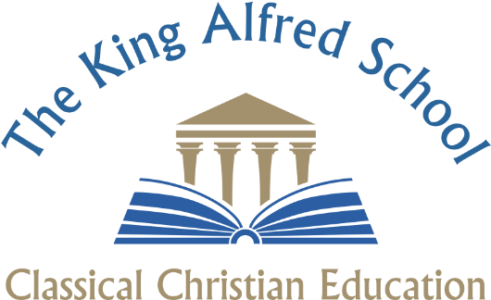

Closing thought
As the days shorten and the Christmas season is on the near horizon, may we ever consider our ways, being sure to watch and pray as stewards of the Gospel, and as those called to love and disciple our children.
On behalf of the CViE Trustees,
With Christian regards -
Michael
M Ridout
Chairman

Copyright © 2022 Christian Values in Education, All rights reserved.
You are receiving this email because you subscribed to our mailing list at cvie.org.uk
Our mailing address is:
*Christian Values in Education P.O. Box 273 Cambridge CB24 3FW*
Want to change how you receive these emails?
You can update your preferences or unsubscribe from this list.

